Practical No.9

Write a program that implements the LRU page-replacement algorithm.

Input:-

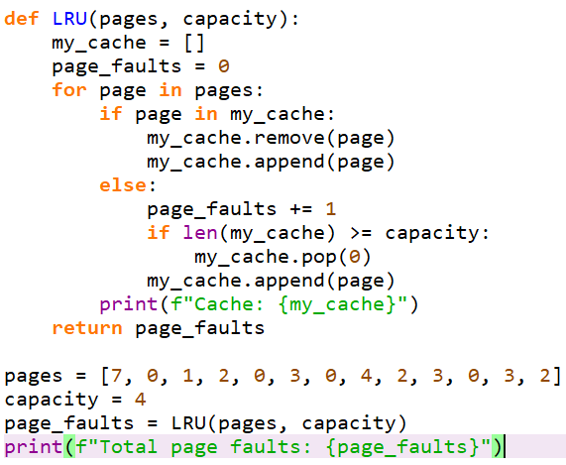

Output:-

